Week7_Fetching User Info with React (fetchuserapp)

Objective:
- Create a React Application “fetchuserapp” which will retrieve the user details from https://api.randomuser.me/ and display the title, firstname and image of a user.
- Create a component named “Getuser” and in the asynchronous method “ComponentDidMount ()” invoke the URL using fetch method and the response can be displayed in the render method of the component.

Phase 1: Setting Up Your Development Environment
Step 1: Install Node.js and npm
- Explanation: Node.js is a JavaScript runtime that lets you run JavaScript on your computer. npm is the package manager for Node.js, used to install and manage project dependencies like React.
- Action:
- Open a web browser and navigate to the official Node.js download page: https://nodejs.org/en/download/
Step 2: Install Visual Studio Code
- Explanation: Visual Studio Code (VS Code) is a free, powerful code editor that is highly recommended for React development.
- Action:
- Go to the official VS Code website: https://code.visualstudio.com/
- Download and run the installer for your operating system.

Phase 2: Creating and Running the React Application
Step 3: Create the React Application
- In your command prompt or terminal, navigate to the directory where you want to store your project (e.g., your Desktop or a development folder).
- Type the following command and press Enter. This may take a few minutes to complete.
npx create-react-app fetchuserapp
Step 4: Navigate into Your New Project Folder
- You must be inside the project folder to run commands related to this specific application.
- Once the command from Step 4 is finished, type the following command to move into the newly created directory:
cd fetchuserapp
Step 5: Open the Project in Visual Studio Code
- This command opens the entire project folder in VS Code, allowing you to easily browse and edit the project files.
- Type the command:
code .
Note: The . tells VS Code to open the current directory.

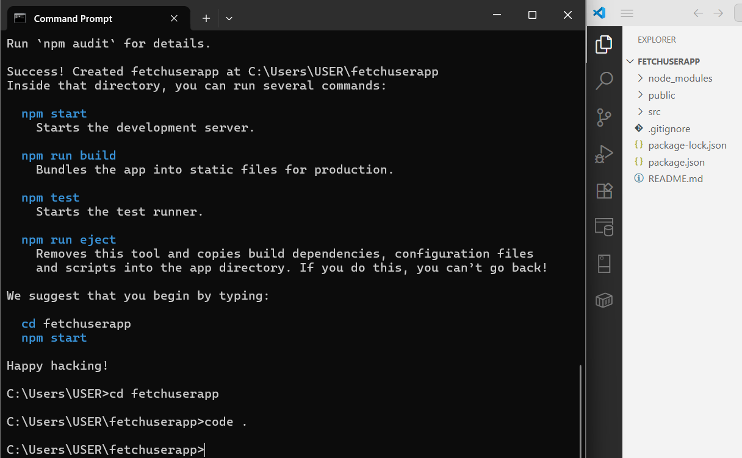
Step 6: Create the Getuser.js File
- In the VS Code explorer, right-click the src folder.
- Select "New File" and name it Getuser.js.
// src/Getuser.js
import React from "react";
class Getuser extends React.Component {
constructor() {
super();
this.state = {
person: null,
loading: true,
};
}
async componentDidMount() {
const url = "https://api.randomuser.me/";
const response = await fetch(url);
const data = await response.json();
this.setState({ person: data.results[0], loading: false });
console.log(data.results[0]);
}
render() {
const { loading, person } = this.state;

if (loading) return <h3>Loading...</h3>;

return (
<div style={{ textAlign: "center", marginTop: "30px" }}>
<h2>
{person.name.title} {person.name.first} {person.name.last}
</h2>
<img src={person.picture.large} alt="User" />
</div>
);
}
}
export default Getuser;
Step 7: Edit the Main App.js File
- Open the App.js file from the src folder.
- Replace all of its content with this code:
// src/App.js
import React from "react";
import Getuser from "./Getuser";
function App() {
return (
<div>
<Getuser />
</div>
);
}
export default App;

Step 8: Run the Application
- Go back to your terminal (it should still be in the fetchuserapp folder).
- Run the start command:
npm start

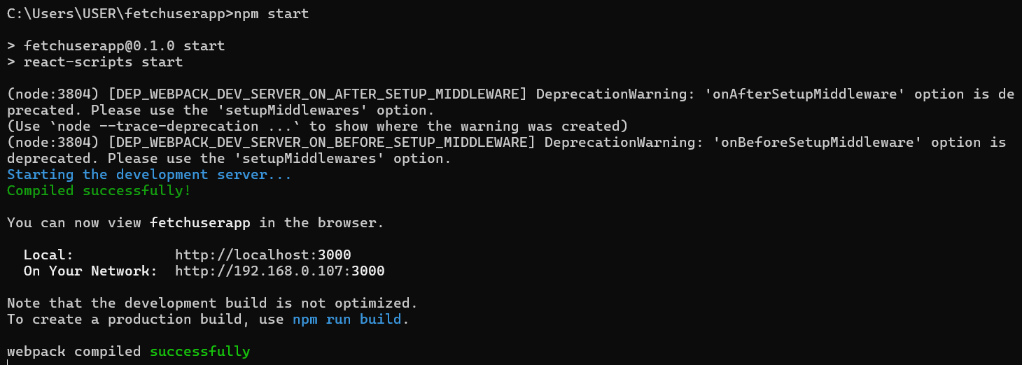
Step 9: View Your Application
- The development server hosts your application on a local port, typically 3000.
Local: http://localhost:3000
On Your Network: http://192.168.0.107:3000

Output:

